Who Profits?
It is a yearly tradition in this blog to simultaneously discuss 1) what makes Thanksgiving worth celebrating and 2) to set the record straight by articulating the first point clearly and refuting the nonsense that tries to drown it out. This year’s column is no different, although the message comes in particularly well-worded argument by Dinesh D’Souza… but more on that later.
First, just what makes the holiday worth celebrating? (Hint it isn’t a day off, turkey dinner with friends and family, football games, or Black Friday – although the first three of those are nice.) It is the idea that economic freedom, specifically in the form of private property ownership and voluntary exchange of goods and services, is the ‘magic’ that makes us all prosperous. Of course, the ‘secrets’ to this magic are nothing more than the recognition that different people are made differently, have different interests and abilities, and, above all, different drives, and the faith that people, left to their own devices, will generally want to cooperate to the betterment of all.
Second, just why does the record need straightening out? Well there are two reasons. On one hand, there is simply a lot of misinformation that clutters up the idea landscape. This economic noise distracts and deceives people from understanding and appreciating what economic freedom means; from appreciating that they control much of what happens in their lives. This ignorance not only spawns poor decision making it also contributes to the overall unhappiness of any afflicted by it. On the other hand, there is a certain class of people unwilling to trust that their fellow citizens can manage their own affairs. This professional busybody class is always poking its collective nose into everybody else’s affairs seeking to dictate and control things that aren’t any of their business. Ironically, but not unexpectedly, these type of people never subject themselves to the autocratic rule they wish to subject others under.
The story of the first Thanksgiving (nicely summarize here) centers around the Pilgrims realizing that private property and economic freedom matter (see also How Private Property Saved the Pilgrims). Sadly, this fundamental message is warped and twisted – sometimes innocently, sometimes maliciously – with off-the-mark commentary and argumentation that simply ‘doesn’t follow the science’ (the dismal science of economics that is). A previous post dealt with some of the most distressing criticisms of the holiday and tried to set some small corner of the record straight but there is always a need for more.
This is where Dinesh D’Souza comes in. I recently came across a lecture he made in which he presented ideas that solidly support just why the real story of Thanksgiving is worth remembering. He didn’t tie these ideas directly to the pilgrims so that will be the contribution I provide here.
The tale that Dinesh tells involves a valet car attendant who parks cars at a luxurious resort. On average the attendant works 10 hours in a day for which he makes $150 ($15/hour). Over the course of that day he parks 100 cars (10/hour) at the price of $30/car. The total revenue the resort earns $3000.
<iframe width="560" height="315" src="https://www.youtube.com/embed/mYbambvmWMs" title="YouTube video player" frameborder="0" allow="accelerometer; autoplay; clipboard-write; encrypted-media; gyroscope; picture-in-picture" allowfullscreen></iframe>
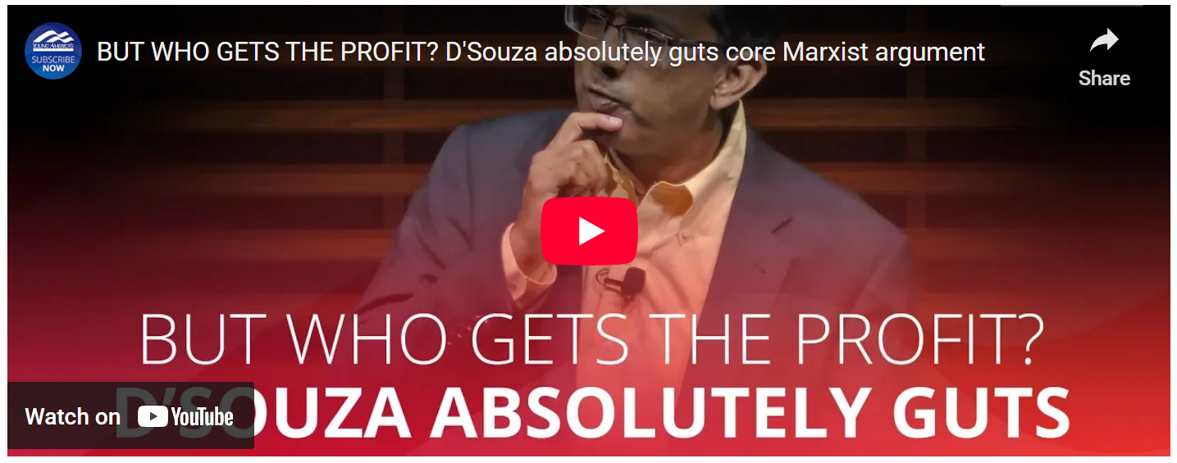
D’Souza then discusses how the Marxist looks at what he perceives as an inequity: the valet, as the main agent, is the one providing the service with his labor but he is only getting a small fraction (5%, in fact) of the revenue. D’Souza goes on to say (although some inference is needed as there is a cut in the edit) that once the operating costs are subtracted there is still a substantial profit that flows to the owners (the capitalists) which bypasses the valet entirely. He summarizes Marx’s objection as centering on the fact that the capitalist (precise definition to follow) has already had his recompense through the interest and that the profit should go to the laborer as he is the only one actually producing a ‘good’ in this scenario.
D'Souza then goes on to point out the obvious flaw in this argument. In Marx’s point-of-view, the capitalist’s only function is to provide the financial power to start the business. D’Souza correctly points out that the owner (or what he calls capitalist with a more widely expanded definition) does far more than supply working money. The owner provided three essential ingredients that make his portion of the profit much higher than that of the valet’s:
- Conception – the owner conceived of the idea of the resort with the necessary appeal to attract people willing to pay $30/day to have their car parked
- Realization – the owner turned the conception into reality by organizing the countless details, large and small, that make an idea a reality
- Protection – the owner gets paid last and provides a bulwark against the ebbs and flows of the business cycle to labor thereby giving labor the security of steady wages at the expense of lower profit.
So, how does this narrative tie back into Thanksgiving? Well, the same passions and resentments that showed up in the valet’s Marxist criticism of the resort’s profit were on display in Plymouth all those years ago. However, Marx’s facile explanation in terms of the friction between labor and capital doesn’t work so well for the case of the Pilgrims. The capital for the founding the Plymouth Plantation came from the Company of Merchant Adventurers of London, who remained behind in the old world and, thus, were as far away as conceivably possible at that time (separated by the Atlantic in the early 1600s). If Marx’s view were correct, why didn’t this laborer’s paradise work from the first go?
William Bradford, who chronicled the events in the fledgling colony, identified how working in common was ‘found to breed much confusion and discontent’. That the most able bodied complained that they had to ‘spend their time and strength to work for other men’s wives and children without any recompense’. Where is the worker’s utopia that Marx promised once the worker was freed of the shackles of capital.
In 1623, Bradford took the bold step of abolishing communal labor in favor of private ownership and responsibility. He turned each family into owners of their own land and a bounty ensued. In other words private not communal ownership corrected the problem.
To be fair, some of Marx’s observations about the exploitation of the some for the enrichment of others are valid. Adam Smith also raised concerns about these situations and, as a moral and just society, we should look for mechanisms to address these things. But the answer, contrary to Marx, isn’t ridding ourselves of private ownership. Rather, we should be expanding opportunities for more people to own some part of the economic means of production. As a society, we should offer opportunities for the valet (assuming he is resentful of the role he plays at the resort) to open his own business. In short, we should reject Marx and embrace Bradford.

